Lidar Navigation.

I modeled a Drone flying above this surface.

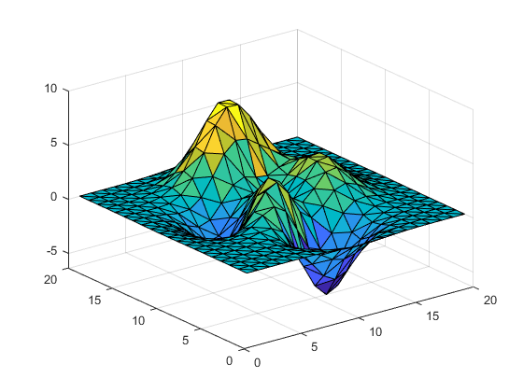

The Drone is located at: (x,y,z,yaw,pitch,roll) = [10.1 10.1 10 0 0 0]

I make an initial guess for where the drone is = [11 8 8 1 1 1]

Results – The Blue curve (virtually covered by the yellow) is the “Correct” Lidar measurement. This is what the lidar range returns at its true location. The red is the lidar readings using the initial guess. The yellow shows the lidar readings after minimizing the error. Error between the curves is defined as the average absolute value between distances. The magnitude of the initial error is 2.7955. The magnitude of error after minimizing is 0.0144. It takes 82 seconds to compute.



Let’s talk.